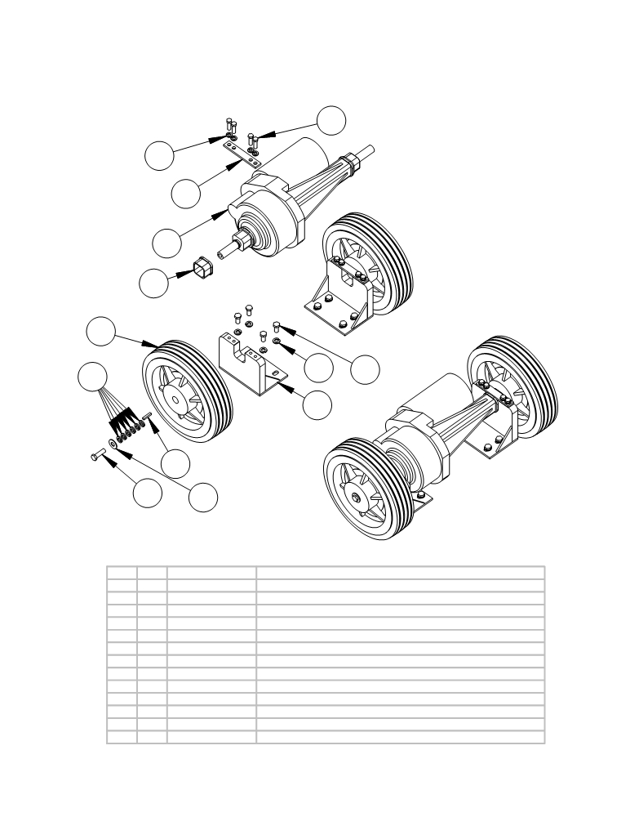

TRANSAXLE ASSEMBLY AND PARTS LIST

7

5

3

1

13

4

9

11
8 10

 | ITEM | SKU | DESCRIPTION | QTY
 | 1 | E10509 | Transaxle 36V | 1
 | 2 | E11589 | TRANSAXLE BRACKET | 2
 | 3 | E11590 | TRANSAXLE RETAINER | 2
 | 4 | E11631 | 10"x2 1/2" Transaxle Wheel | 2
 | 5 | E81067 | Washer, 5/16" Lock | 16
 | 6 | E81080 | Bolt 3/8-16x3/4 | 8
 | 7 | AS26/32337 | #N/A | 8
 | 8 | E83629 | Screw, 3/8" - 16 x 1.25 Hex Head | 2
 | 9 | E81066 | Washer, 3/8" Split Lock, Zinc | 12
 | 10 | AS26/32283 | #N/A | 2
 | 11 | E11721 | 3/16x3/16x1-1/4" KEYSTOCK | 2
 | 12 | E81066 | Washer, 3/8" Split Lock, Zinc | 8
 | 13 | E12541 | Rubber Mounting Sleeve | 2

ITEM QTY. PART NO.
1 1 AS26051
2 2 AS26/321147
3 2 AS26/321148
4 2 AS26/321383
5 16 AS26/32293
6 8 AS26/32210
7 8 AS26/32337
8 2 AS26/32212
9 12 AS26/32292
10 2 AS26/32283
11 2 AS26/32336
12 8 AS26/32292
13 2 AS26/322002

12 6

2

DESCRIPTION
Transaxle
Transaxle Bracket
Transaxle Retainer
Wheel 10 inch (keyed for Transaxle) Lock washer
Bolt
Bolt
Bolt
Lock washer
Washer
Key for transaxle
Lock washer
Rubber mounting sleeve

- 39 -

